Dual Port RAM Implementation on FPGA with Verilog and System Verilog - Driven Testbenches

Chakala Santhi Priya
B. Tech Student
Department of EECE
GITAM University
Bangalore, India
Santhi.priyac925@gmail.com

Pranitha .M
B. Tech Student
Department of EECE
GITAM University
Bangalore, India
Pranithamakkinei07@gmail.com

Keerthi.N
B. Tech Student
Department of EECE
GITAM University
Bangalore, India keerthi94409@gmail.com

Abstract— Dual-Port Random Access Memory (RAM) offers two independent ports for simultaneous access, with the capability for read and write operations simultaneously. This design maximizes data transfer and is popularly applied in parallel processing, video processing, and network applications. A Dual-Port RAM was designed and implemented in Verilog on an FPGA platform. The design enables independent addressing on a per-port basis and provides conflict resolution to ensure data integrity when there are multiple accesses to the same memory address. System Verilog test benches were written to test functionality, timing, and performance under different conditions. Synthesis, simulation, and verification were conducted with Xilinx Vivado on an Artix-7 FPGA. The design shows effective memory usage with optimized resource usage and safe concurrent access management.
Keywords — Dual-Port RAM, FPGA, Verilog, System Verilog, Xilinx Vivado, Concurrent Access, Parallel Processing.

Introduction
The demand for high-performance memory architectures in digital systems has necessitated efficient Dual-Port RAM (DPRAM) designs, supporting read and write operations on two independent ports concurrently. DPRAM is vital in parallel computing, networking, and real-time embedded systems for its ability to increase data throughput and system efficiency [1]-[5]
Various works have investigated FPGA-based designs of Dual-Port RAM based on Verilog and VHDL, with regard to design efficiency, power minimization, and performance scalability [6]-[10].
Though hardware implementation is the focus of most studies, verification is a crucial issue, with checking functionality over varying operating conditions being crucial for real-world deployment [11]-[15]. SystemVerilog-based testbenches provide a sophisticated verification technique, allowing functional verification, corner-case verification, and automatic verification with tools like Universal Verification Methodology (UVM) [16]-[20].
In this paper, we introduce "Dual Port RAM Implementation on FPGA with Verilog and SystemVerilog-Driven Testbenches." The design is done using Verilog to model RTL and SystemVerilog for higher-level verification, which makes it robust under different operational conditions. The implementation of FPGA is done by Xilinx Vivado with synthesis, simulation, and hardware testing to analyze performance, power consumption, and resources used.
Existing studies of DPRAM [21]-[29] present numerous optimization methods, which we utilize in this work to improve scalability, power consumption, and verification methods. Combining effective Verilog-based modeling with systematic SystemVerilog verification, this research elevates FPGA-based memory architectures to make high-speed, low-power, and scalable memories a reality for future digital systems..

SYSTEM MODEL
The Dual-Port Random Access Memory (RAM) is intended for two independent operations—read and write—to be performed simultaneously. Both operations are able to access distinct memory locations without affecting one another, enhancing the speed of data transfer. This memory is typically applied in applications like parallel processing, video processing, and networking, where simultaneous and quick access to memory is crucial. Dual-Port RAM is developed on the Xilinx Artix-7 FPGA by employing the Verilog as hardware description language. The width of the memory is 8 bits and the depth is 16 locations, accessed by a 4-bit address. Port A is utilized to write data to memory and Port B is utilized to read data from memory concurrently. The system operates with two addresses: One for writing data to memory. One for reading data from memory. Every address is chosen independently, which enables the RAM to read and write in parallel without interference between both ports. Dual-access enhances the performance of the system and facilitates quicker data processing in real-time systems.
To carry out write operations, the Write Enable signal triggers the operation. Data to be written is presented to the memory, whereas the write address addresses the precise memory location at which data is written. The read address also addresses the memory location's data being read simultaneously. Output of the read operation is transmitted to the output port, which may be watched or utilized by other components in the system.
The system is deployed on the Nexys 4 DDR development board, which contains the Xilinx Artix-7 XC7A100T FPGA. The board has plenty of logic cells, DSP slices, and block RAM and is thus well suited for the implementation of high-performance, scalable memory systems. The platform is also capable of real-time testing and validation via onboard peripherals like switches and LEDs.

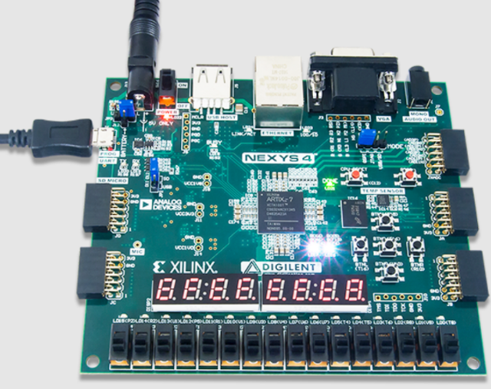
Fig1. shows the Artix-7 FPGA Nexys 4 implemented in this design.

The design exploits the FPGA's on-chip Block RAM (BRAM) or distributed RAM to store data compactly. It also takes advantage of simple control signals and a friendly user interface for testing and verification purposes. In a standard test application, switches on the development board are employed to provide data input, address selection, and control over the write operation, and read results are indicated on onboard LEDs. This configuration allows the system to be tested in real-time and correct operation checked easily.
The Dual-Port RAM architecture has control logic for managing access to the same memory address by both ports simultaneously. In a conflict case, for example, when one is writing and another is reading the same address, conflict resolution provides predictable and consistent behavior. This ensures data integrity and makes the system function correctly, even under concurrent access scenarios.
This Dual-Port RAM implementation provides an optimal and scalable memory solution for FPGA applications with efficient data access at high speed, together with flexibility for scaling for large designs in the future.

SYSTEM ARCHITECTURE
This project creates an 8-bit Dual-Port RAM on a Xilinx Artix-7 FPGA with the Nexys 4 DDR board. The RAM utilizes the FPGA's Block RAM (BRAM) to execute read and write operations concurrently.
Two independent ports are available: one to read data and another to write data. A write enable signal controls the write operation. Switches on the board are utilized to input data and addresses, while LEDs show the read data, allowing for simple system testing.
The RAM contains 8 bits of information in each of 16 addresses. The system uses a 100 MHz clock sourced from the FPGA. A reset signal resets the RAM by forcing all memory addresses to zero whenever required.

Table 1: FPGA Pin Assignment and Signal Description
Signal | Pin | Function
clk | Clock (100 MHz) | clock input
write_enable | SW0 (U9) | Write enable control
data_write[7:0] | SW7–SW0 (U9 to V2) | 8-bit data input for writing
addr_write[3:0] | SW11–SW8 (T3 to T1 | 4-bit address input for writing
addr_read[3:0] | SW15–SW12 (P4 to P2) | 4-bit address input for reading
data_read[7:0] | LED7–LED0 (T8 to U6) | 8-bit data output to LEDs
The Dual-Port RAM system runs in synchronous mode, driven by the onboard 100 MHz clock of the Nexys 4 DDR FPGA board. All operations,reading from or writing to memory are initiated on the rising edge of the system clock, providing predictable and reliable data handling. During system initialization, the reset signal is watched. If reset is asserted (logic high), every memory location within the RAM is set to zero. This ensures a known initial state, which is necessary for predictable system operation and debugging. When the reset is cleared, operations can commence normally. The system constantly checks the write enable signal: If write enable is asserted (high, 1), a write operation is issued. The user supplies: Write address via switches SW11–SW8. Data to be written via switches SW7–SW0. On the subsequent clock edge, the input data is written into the memory location that the write address specifies. When write enable is low (0), a read operation occurs. The system: Reads data from the memory address the switches SW15–SW12 specify. The 8-bit output data appears on the board's LEDs LD7–LD0 in real time. This operation allows users to access the RAM through easy-to-use hardware interfaces: switches for inputs and LEDs for outputs. The architecture accommodates concurrent read and write access via two separate ports, ensuring the optimal efficiency of data transfer and demonstrating the ability of FPGA Block RAM (BRAM) resources. Responsiveness of the system relies on the synchronous clock to update or access data on every valid clock cycle.
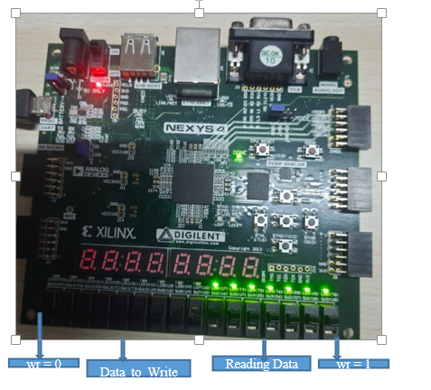
Fig 2. Representation of Pins on FPGA Kit.

The operation of the dual-port RAM system's flow is represented in Figure [3]. The process starts with a reset at the beginning, where the memory locations are all reset. Based on the write enable signal state, the system either executes a write operation—storing the input switch data into the indicated memory address—or a read operation, reading from memory and outputting to the LEDs. The system is synchronous and reacts to every clock cycle. 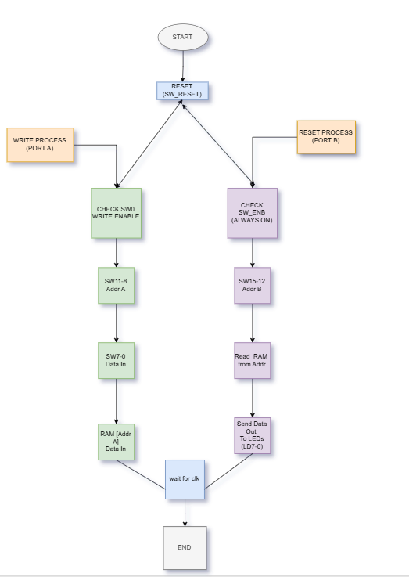

Fig 3. Flow Chart

The system first checks the reset signal. When reset is active, all of the memory locations in the RAM are reset to zero. After reset is removed, the system checks the write enable switch.
When the write enable is active, the system writes data from the input switches (SW7 through SW0) to the RAM at the address determined by the write address switches (SW11 through SW8).
If write enable is off, the system reads the data from the RAM at the address indicated by the read address switches (SW15 through SW12). The read data are displayed on the LEDs (LED7 through LED0). The process operates in a continuous manner with operations carried out on every clock cycle. The flowchart illustrates the sequential operation of the system.

Steps of Operation:
Start
The system is in operation when powered on.
Reset
Check When the reset signal is asserted (rst == 1), the memory locations across the RAM are set to zero, providing a known start condition.
Write Enable
Check The system inspects the write_enable signal (controlled by SW0).
If write enable is asserted (SW0 == 1): The system writes data into RAM.
The write address is derived from switches SW11 through SW8.
The switches SW7 to SW0 contain the data to write.
The data is in the RAM at the given address.
When write enable is off (SW0 == 0):
The system does a read. The address for the read is given by switches SW15 to SW12.
The data from the RAM at the address is read and shown on LEDs LED7 to LED0.

RESULTS AND DISCUSSION
The simulation waveform in Figure [4] illustrates the functionality of a dual-port RAM implemented in Verilog. The implementation supports the simultaneous read and write operations on two independent ports. The clk (clock) signal clocks both the read and write operations. At 50 ns, the we (write enable) signal is driven high, enabling data 01010101 to be written into memory address 0100. Later, at 60 ns, another write stores data 10101010 at address 1000. Following the write operations, when the we signal is deasserted (logic 0), the memory goes into read mode. The read operation reads the stored data from address 1000 and outputs 10101010 on the data_out lines. This waveform confirms the proper operation of the dual-port RAM, demonstrating its capability to perform read and write operations concurrently without interference.

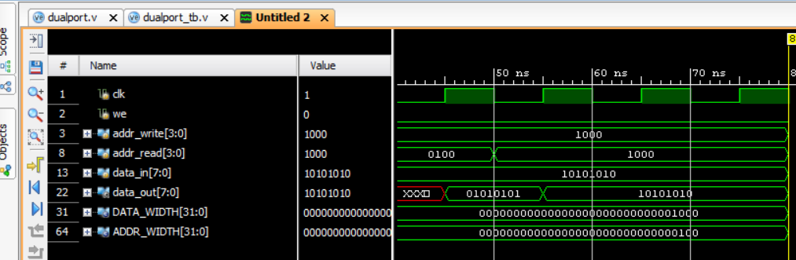

Fig 4: Simulation waveform of Dual-Port RAM read and write operations using Verilog

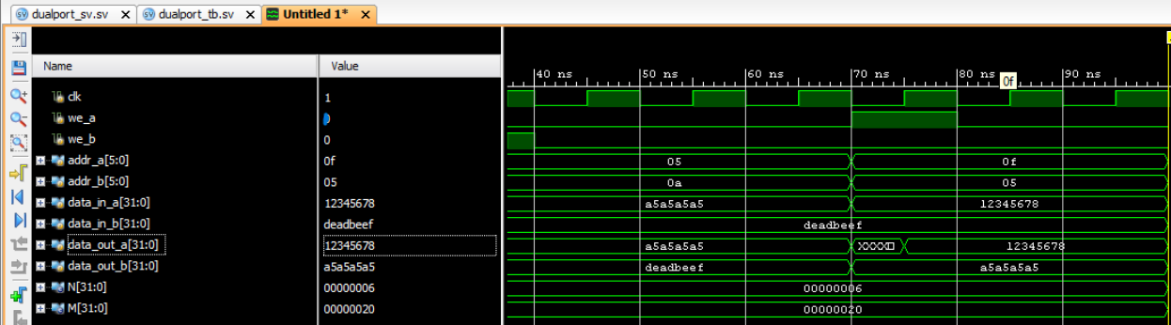
Fig 4a : Simulation waveform of Dual-Port RAM read and write operations using System Verilog
At 50 ns, port A writes data 12345678 to address 05. Simultaneously, port B reads from address 0A and receives the value a5a5a5a5. Then at 70 ns, port B writes deadbeef to address 0A. Subsequently, port A reads from address 0A and receives deadbeef. Port B reads from address 05 and receives 12345678. This indicates the dual-port RAM can read and write simultaneously through two ports.

FPGA IMPLEMENTATION RESULTS.

As shown in the figure, the memory works by using the switches on the FPGA board. SW0 is used to turn on the write function. The data to write is given through switches SW7 to SW0. The address where the data is stored is selected by SW11 to SW8. At the same time, the data from the address selected by SW15 to SW12 is read and shown on the LEDs. This shows that the memory can write data to one address and read data from another address at the same time.

Fig. 6. FPGA Implementation of

Start
The system is in operation when powered on.
Reset
Check When the reset signal is asserted (rst == 1), the memory locations across the RAM are set to zero, providing a known start condition.
Write Enable
Check The system inspects the write_enable signal (controlled by SW0).
If write enable is asserted (SW0 == 1): The system writes data into RAM.
The write address is derived from switches SW11 through SW8.
The switches SW7 to SW0 contain the data to write.
The data is in the RAM at the given address.
When write enable is off (SW0 == 0):
The system does a read. The address for the read is given by switches SW15 to SW12.

The data from the RAM at the address is read and shown on LEDs LED7 to LED0

V APPLICATION

There are different kinds of memory employed to hold and manage data in electronic devices. RAM holds data temporarily and erases data after storing it in permanent storage. SRAM holds data that is used again frequently for quick access and also erases the data after permanently storing it. DRAM holds programs and data temporarily, and once the information is saved, it erases stored data. Dual-Port RAM enables two processors to simultaneously access memory. A processor saves data locally while the other saves the data in the cloud. Once both these operations are finished, the Dual-Port RAM is released. This makes Dual-Port RAM ideal for those applications that require quick and concurrent data handling.

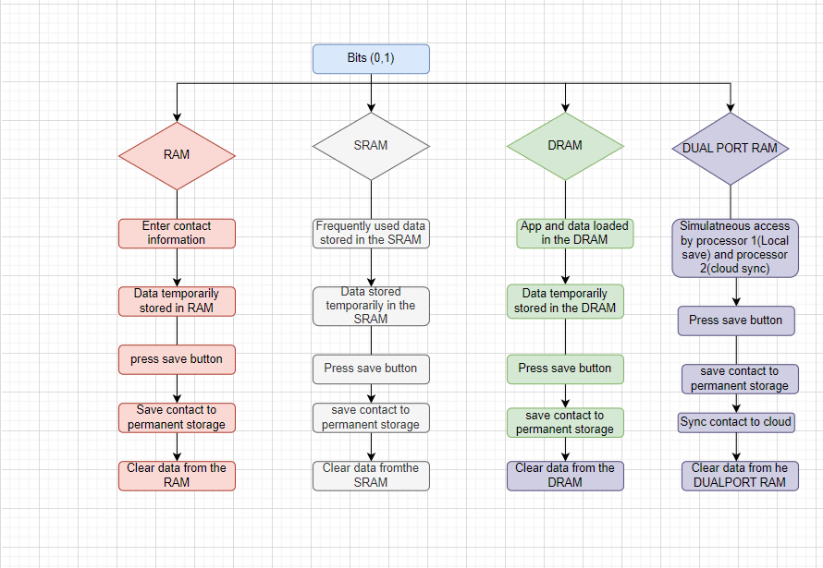

Fig 7. Flow chart of the Application

The flowchart explains how different types of memory work. RAM temporarily stores data until it is saved to permanent storage and then clears the data. SRAM does the same but is mainly used for frequently accessed data, offering faster access. DRAM stores data for applications in use, and after saving to permanent storage, it clears the data. Dual-Port RAM allows two processors to access the memory at the same time—one processor saves data locally, while the other syncs it to the cloud. After saving, the data in Dual-Port RAM is also cleared

v.CONCLUSION

A Dual-Port RAM was successfully designed, simulated, and implemented on an FPGA. The design supports simultaneous read and write operations from two independent ports without data conflicts. Using switches and LEDs on the FPGA board, both writing and reading processes were demonstrated, confirming the correct functionality of the Dual-Port RAM. Its practical application was also explained, such as local data saving and cloud synchronization, showcasing its usefulness in real-world scenarios. The implementation highlights the efficiency and flexibility of Dual-Port RAM for applications that require high-speed data access from multiple processors. This work provides a strong foundation for further advancements in memory system design for parallel processing and real-time systems. The authors declare that they have no conflict of interest.

. References
[1] S. Karthik, K. Deepa, “Design and Implementation of Dual-Port RAM on FPGA Using Verilog,” International Journal of Innovative Research in Computer and Communication Engineering, Vol. 3, Issue 7, July 2015.
[2] S.S. Bhattacharyya, A. Banerjee, “High-Performance Dual-Port SRAM Design Using FPGA,” IEEE International Conference on Electronics, Communication and Aerospace Technology, 2017.
[3] M. Patel, S. Shah, “FPGA Based Design and Implementation of Dual-Port RAM Using VHDL,” International Journal of Advanced Research in Computer Engineering & Technology, Vol. 3, Issue 8, August 2014.
[4] P. Sharma, A. Sharma, “Design and Implementation of High-Speed Dual-Port RAM for Image Processing Applications,” International Journal of Computer Applications, Vol. 112, No. 5, February 2015.
[5] A. B. Adewale, I. M. Ezenwoye, “Implementation and Performance Analysis of Dual-Port RAM on FPGA,” International Conference on Computational Science and Computational Intelligence (CSCI), 2017.
[6] S. K. Bhoi, P. R. Sahu, “Design and FPGA Implementation of Dual-Port RAM Using Verilog,” International Journal of Engineering Research and Technology (IJERT), Vol. 3, Issue 5, May 2014.
[7] K. Rani, N. Prasad, “Design and Verification of Dual-Port RAM Using System Verilog,” International Journal of Engineering and Advanced Technology (IJEAT), Vol. 8, Issue 6, August 2019.
[8] M. S. Pattan, M. I. Kazi, “Efficient Design of Dual-Port RAM for FPGA Using VHDL,” International Journal of Research in Engineering and Technology (IJRET), Vol. 2, Issue 10, October 2013.
[9] A. Bhatnagar, P. Verma, “Implementation of Synchronous Dual-Port RAM Using Verilog for FPGA,” International Journal of Computer Applications, Vol. 73, No. 5, July 2013.
[10] D. Singh, R. Pal, “FPGA Implementation of Parameterized Dual-Port RAM,” International Conference on Computing, Communication and Automation (ICCCA), 2017.
[11] S. K. Kumar, R. M. Chandrasekaran, “Design and Verification of Dual-Port RAM for Network Processors,” International Journal of Computer Science and Mobile Computing, Vol. 6, Issue 4, April 2017.
[12] P. Ezhumalai, R. Saminathan, “Design and Simulation of Dual-Port RAM Using Xilinx ISE,” International Journal of Advanced Research in Electrical, Electronics and Instrumentation Engineering, Vol. 4, Issue 3, March 2015.
[13] N. V. Kale, A. B. Rao, “Design of Dual-Port RAM for Image Processing Applications Using Verilog,” International Journal of Advanced Research in Computer and Communication Engineering, Vol. 5, Issue 2, February 2016.
[14] P. Kumar, A. Kumar, “Efficient Dual-Port RAM Architecture for High-Speed Data Processing,” International Journal of Advanced Research in Computer Science, Vol. 8, No. 7, July 2017.
[15] R. M. Keshari, V. R. Singh, “Design and Implementation of Dual-Port RAM on FPGA for Data Communication,” International Journal of Science and Research (IJSR), Vol. 4, Issue 6, June 2015.
[16] S. Sharma, K. Mehta, “Low Power Dual-Port SRAM Design for FPGA-Based Processors,” International Journal of Scientific and Research Publications, Vol. 3, Issue 7, July 2013.
[17] A. Sinha, M. R. Bhatnagar, “Design of Asynchronous Dual-Port RAM for High-Performance Applications,” International Journal of Computer Applications, Vol. 93, No. 4, May 2014.
[18] R. Mahajan, R. K. Garg, “Design and Simulation of Dual-Port RAM for FPGA-Based Systems,” International Journal of Emerging Trends in Electrical and Electronics (IJETEE), Vol. 11, Issue 3, January 2015.
[19] J. J. Ratnakar, K. B. Gowda, “Implementation of Dual-Port RAM with Priority-Based Conflict Resolution,” International Conference on Emerging Trends in Engineering and Technology, 2016.
[20] V. Bhosale, S. Rajguru, “Design and FPGA Implementation of Dual-Port RAM with Error Correction,” International Journal of Engineering Trends and Technology (IJETT), Vol. 25, No. 5, July 2015.
[21] M. Kaur, A. Singh, "Implementation and Analysis of Dual-Port RAM on Spartan FPGA Using Verilog," International Journal of Advanced Research in Computer and Communication Engineering, Vol. 6, Issue 4, April 2017.
[22] R. Agrawal, V. Patel, "Design and FPGA Implementation of Low Power Dual-Port RAM," International Journal of Scientific Engineering and Research (IJSER), Vol. 5, Issue 6, June 2017.
[23] S. Dinesh Kumar, R. Deepak, "Efficient Design of Dual-Port RAM for Digital Signal Processing Applications," IEEE International Conference on Communication and Signal Processing (ICCSP), 2015.
[24] A. S. Pawar, P. A. Khandagle, "FPGA Implementation of High-Speed Dual-Port RAM Using VHDL," International Journal of Engineering Development and Research (IJEDR), Vol. 6, Issue 3, 2018.
[25] M. Ahmed, K. A. Bakar, "Performance Analysis of Dual-Port RAM on FPGA for Video Processing Applications," International Journal of Engineering and Technology (IJET), Vol. 8, No. 2, 2016.
[26] R. Dubey, P. Mishra, "Design and Implementation of Dual-Port RAM Using System Verilog for SoC Design," International Journal of Computer Science and Mobile Computing (IJCSMC), Vol. 8, Issue 7, July 2019.
[27] N. Gupta, M. Singh, "Design and FPGA Implementation of Dual-Port RAM with Separate Read/Write Clocks," International Journal of Engineering Science and Computing (IJESC), Vol. 7, Issue 5, 2017.
[28] H. P. Suryawanshi, S. M. Kurhekar, "Design and FPGA Implementation of Low-Power Dual-Port SRAM," IEEE International Conference on Advances in Electronics Computers and Communications (ICAECC), 2014.
[29] A. Sharma, P. Bhattacharya, "High-Speed Dual-Port RAM for FPGA-Based Real-Time Systems," International Journal of Science and Research (IJSR), Vol. 4, Issue 11, November 2015.
[30] M. S. Rani, K. Jayashree, "Design and Verification of Dual-Port RAM Using System Verilog UVM," International Journal of Research and Analytical Reviews (IJRAR), Vol. 6, Issue 2, June 2019.

